# Test screen shots Iteration 2:

2.1

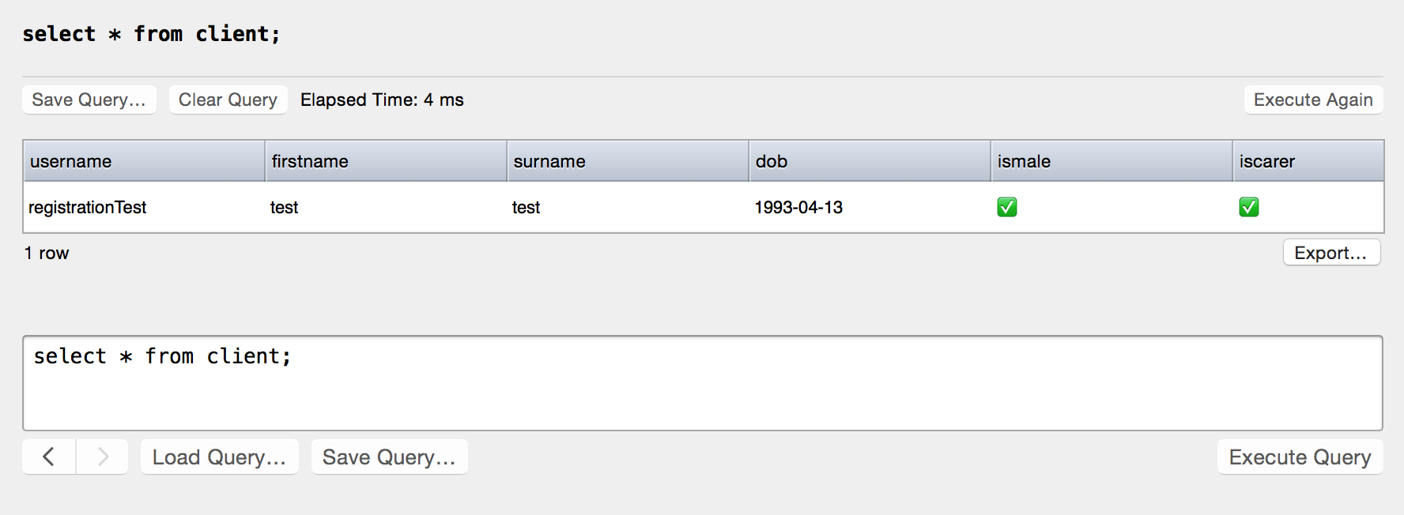

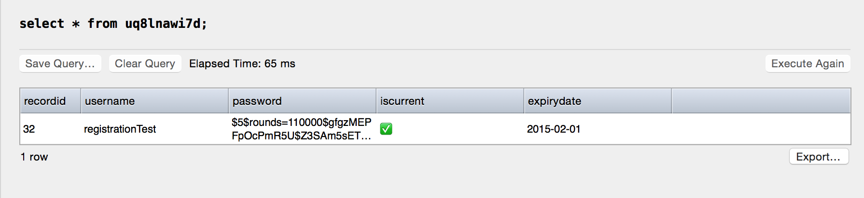

2.2.1

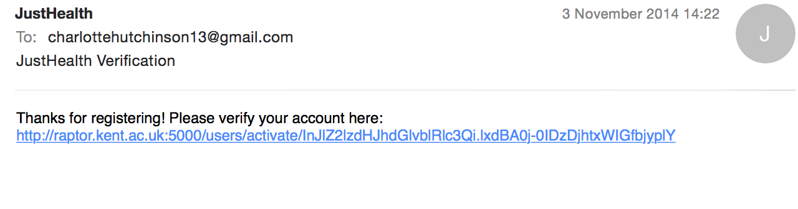

2.2.3

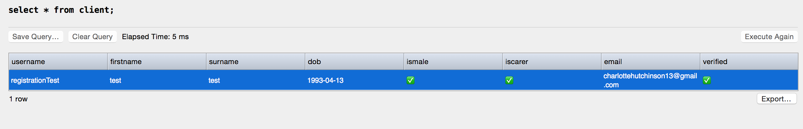

2.4.2

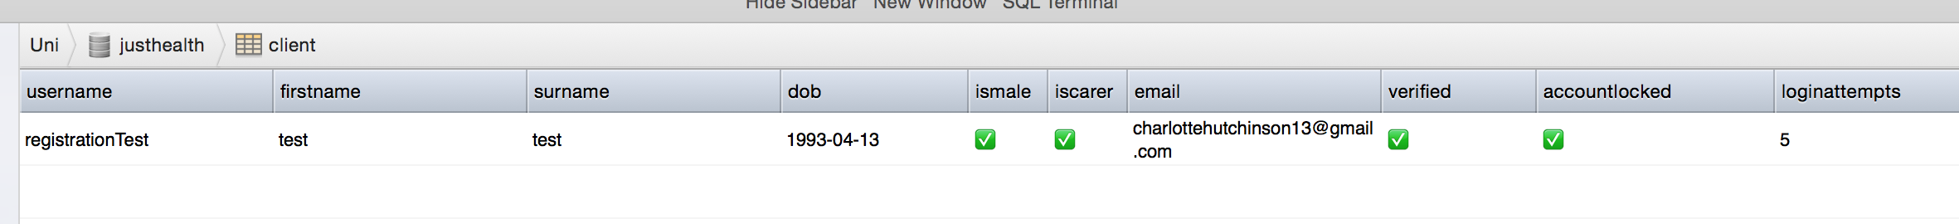

2.4.3

